DSA REPORT ASSIGNMENT 3:

Following are the tables for the 10 different input files given. In every case a and b take values 3 and 5 respectively and number of buckets vary from 2, 5,10, 20.

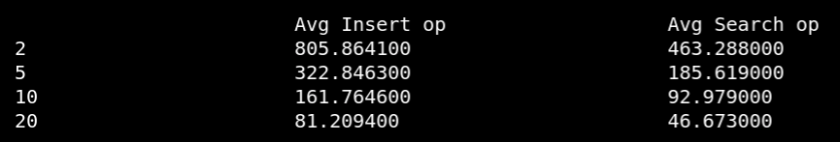
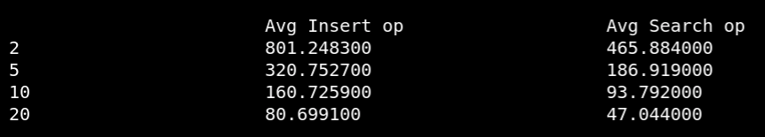
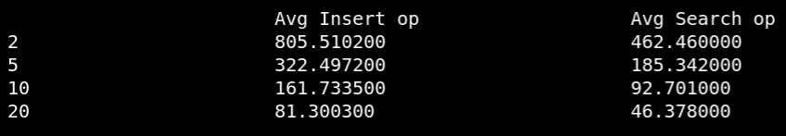
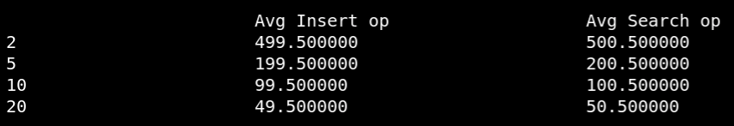
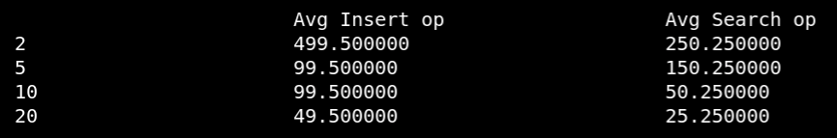

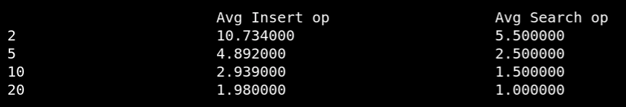
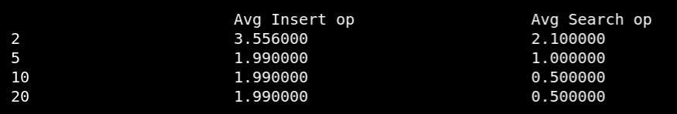
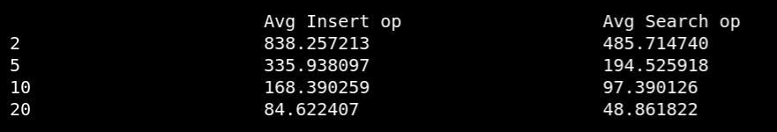

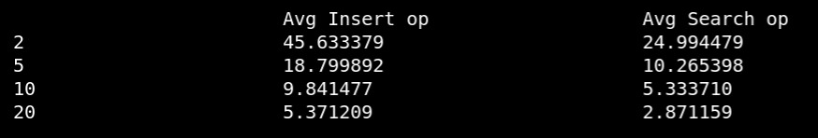

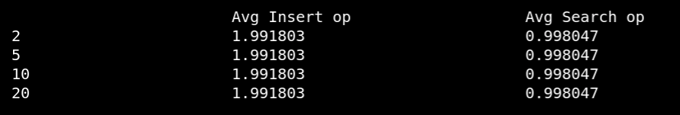

There is less number of operations required when number of buckets are 20, which is because when there are more number of buckets, the items inside a bucket will be much lesser that is there will be less collision so to access an item inside a bucket, we must traverse less number of items when compared to when there are more buckets.

